UA-OSM: Uncertainty-Aware Object-Shaped Merging to Reduce Object Loss in 360° Surround-View Stitching
Rohit Joshi
EIMT, Switzerland (ORCID 0009-0007-4201-7862)

Abstract—Surround-view systems stitch four fisheye cameras into a top view used for parking. Near the vehicle corners, two cameras project a standing person in different directions, and the merge seam can crop both copies, so a child can disappear from the display. We show that straight seams, even dynamic ones, cannot preserve objects in a zone around the corner whose size depends on the admissible seam range: with seams limited to 15–75°, 91 % of positions within 0.5 m are unpreservable, falling to 9 % for unrestricted seams. We propose Uncertainty-Aware Object-Shaped Merging (UA-OSM), which assigns each object's complete ground-projected footprint to one camera that detects it, dilates the region by the tracker covariance, resolves conflicts by exhaustive joint camera assignment and escalates to an explicit driver warning. We evaluate with a per-object visibility metric computed on ray-traced renderings rather than on the planning model. On 105 simulated scenes with 8 cm detection error, 100 ms latency and track losses, UA-OSM reduces frames with a lost object from 19.9 % for a straight dynamic seam to 7.0 % (Holm-adjusted p < 10⁻¹²), and from 45.7 % to 20.0 % with five objects. The advantage holds when reversing at a rear corner (32.8 % vs 11.5 %), and under class confusion and phantom tracks. A curved mask-avoiding seam performs worse than the straight seam, and ablations identify joint assignment as the decisive component. We also show that planning-model evaluation overstates performance and that the driver warning fires often with low precision.
Index Terms—Surround view system, image stitching, fisheye camera, vulnerable road users, parallax, multi-object assignment, uncertainty, human–machine interface, SOTIF.
I. Introduction
Surround-view systems (SVS) stitch four fisheye cameras into a single top-down image that drivers use for low-speed manoeuvring and parking [1], [2]. They are now standard in many vehicle segments, and their near field is exactly where vulnerable road users (VRUs) such as children are hardest to see directly [2].
The stitched top view has a known safety flaw. Tall objects violate the flat-ground assumption, so each camera projects them as a radial smear pointing away from that camera. In the overlap zone at each vehicle corner, the two smears point in different directions, and a merge line between them can crop both copies [3]. The object is then partially or completely missing from the display, while the driver assumes the image is complete (Fig. 1).

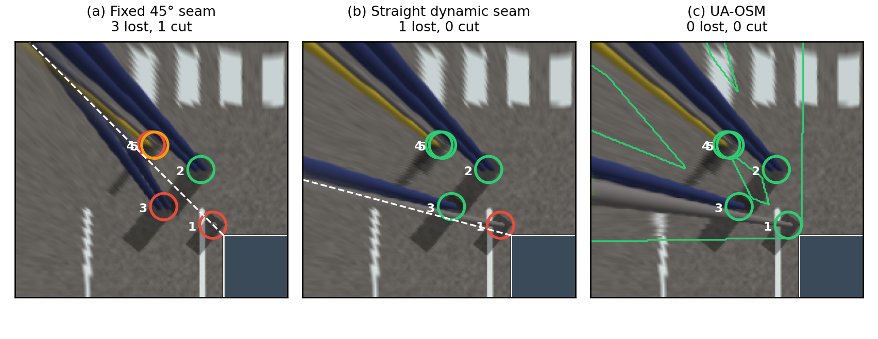
Fig. 1. Crowded front-left corner rendered in the simulator, detection error switched off (five objects; the dark rectangle is the vehicle). Circles mark object bases, coloured by pixel-level status: green visible, orange cut, red lost. (a) Fixed 45° seam: three objects lost and one cut. (b) Straight dynamic seam: the child at the corner (1) is still lost. (c) UA-OSM: all five objects shown whole; green outlines are ownership regions.

This failure is not only cosmetic. Regulations such as UN R158 define test objects and zones behind the vehicle that camera-based reversing systems must make visible to the driver [4], and ISO 21448 (SOTIF) treats such performance limitations under specified conditions as hazards that must be identified and mitigated [5]. Field studies confirm that what the display shows matters: in a study with 111 drivers, a rearview camera reduced collisions with a stationary child-size object, but its benefit depended strongly on where the object was relative to the camera's field of view [6].
A. Limits of Existing Mitigations
Industrial practice has moved from fixed diagonal seams towards dynamic seams that avoid detected objects [7]–[10]. Several disclosures also render an object from a single camera once it is detected in both views [9], [11]. These approaches work well for one object in open space.
Three gaps remain. First, no prior work characterises where a straight or single dynamic seam cannot avoid an object; existing systems either fall back to a default seam [7] or argue that such objects are large enough to remain visible [10]. Our analysis shows the opposite for small VRUs near the vehicle corner. Second, detections are treated as exact, although tracker error of a few centimetres is enough to crop thin objects. Third, objects the detector does not recognise receive no protection, and no existing method tells the driver when the top view cannot be trusted.
We address three research questions. RQ1: Under which geometric conditions can no straight seam preserve an object near the vehicle corner? RQ2: Does assigning whole object footprints to cameras that detect them reduce object loss compared with straight and curved seams, and which component is responsible? RQ3: How robust is the result to detection error, latency, perception faults, parameter choices and a moving vehicle, and how often must the driver be warned?
B. Contributions
This paper makes four contributions:
- Object-level problem formulation. We model the ground-projected footprint of a vertical object for each camera and define Object Visibility Integrity (OVI), a per-object metric of how much of each object survives in the displayed image (Section III).
- Feasibility analysis of straight seams. We derive the condition under which a straight seam preserves an object, map the resulting infeasible zone around the vehicle corner, and quantify its sensitivity to the seam-angle limits, the blend width and object height (Section IV).
- UA-OSM method. We propose Uncertainty-Aware Object-Shaped Merging, which (i) assigns each object's full footprint to one owning camera that actually detects it, (ii) dilates ownership regions by the tracker covariance, (iii) resolves multi-object conflicts by exhaustive camera assignment, and (iv) escalates through a five-level ladder that ends in an explicit driver warning (Section V). A photometric rule for undetected objects is included as a proof of concept.
- Independent evaluation. We evaluate on ray-traced renderings with a pixel-level metric that is independent of the planning model, against four baselines including a curved mask-avoiding seam, with ablations, bootstrap confidence intervals and Holm-corrected paired tests, and under ego motion, reversing, class confusion, phantom tracks, mis-reported covariance and parameter changes. We also show that evaluating with the planning model would have overstated the benefit, and we quantify how often the driver warning fires (Sections VI–VII).
Section VIII discusses HMI and functional-safety implications and threats to validity; Section IX concludes.
II. Related Work
No prior work jointly addresses near-corner infeasibility, detection uncertainty, multi-object conflicts and undetected objects; Table I summarises the gap. The survey is based on searches in September 2026 over publisher sites (IEEE, ACM, Elsevier, SAGE), arXiv, Google Patents and the USPTO full-text database, using combinations of "surround view", "bird's-eye view", "image stitching", "seam", "ghosting", "object disappearance" and "pedestrian" for 2010–2026, plus backward citation tracking. Much of the relevant work is found only in patents, which we cite as disclosed rather than as experimentally validated.
A. Surround-View Synthesis
A classical SVS pipeline performs lens undistortion, geometric alignment to a ground plane or bowl surface, photometric alignment and blending in the overlap zones [3], [12], [13]. Blending ranges from linear feathering to multi-band blending [14]. Photometric harmonisation between cameras remains active, for example by blending ISP white-balance and tone-mapping parameters across adjacent cameras [15]. Bowl-shaped projection surfaces reduce the stretching of distant objects, and 3D surface models such as the burger model improve seamlessness [16]. The near-field perception context, including fisheye camera models and datasets such as WoodScape, is surveyed in [1], [2], [17].
B. Seam Optimisation
Optimal seams are usually found by graph cuts [18]–[20] or dynamic programming [21], with costs built from colour and gradient differences. These methods minimise visible transitions but have no notion of object identity: a seam of minimal colour cost can still pass between the two parallax copies of a person.
C. Object-Aware Dynamic Seams in Automotive SVS
Most work on object-aware merging is found in patents rather than in peer-reviewed literature.
- Seams that avoid objects. One disclosure moves a stitching line so that it never crosses a 3D object and accepts that large objects may remain crossed [10]. NVIDIA's family projects detection or saliency masks from both cameras into the overlap and steers seams of arbitrary shape around them, with temporal filtering and a state machine driven by ego speed, direction and driver gaze [7], [8], [22]. A related disclosure adapts the bowl shape to the distance of the nearest objects [23].
- One camera per object. NIO selects a single camera for an object in the overlap and also describes a mask whose interior comes from one camera [9]. Another granted patent fits contours to the same object in both views and pastes one complete view at a merged position [11]. The idea is older than the recent dynamic-seam work: a 2011 patent already references only one camera inside a detected moving-object region of the synthetic image [24]. A further disclosure labels pixels by the camera with the smallest estimated depth [25]. Objects on the boundary have also been handled by cutting the object out of both camera views and superimposing the parts at the boundary [26], or by replacing the ghost images of a pedestrian with a semi-symbolic graphic [27].
- Quality assessment. Stitching-quality assessment for SVS has been proposed at image level [28]; subjective and objective quality of stitched VR images is studied in [29].
These approaches establish that avoiding or isolating detected objects reduces ghosting. They do not characterise when a seam cannot avoid an object, they treat detections as exact, and none evaluates per-object visibility.
D. Parallax-Tolerant and Learned Stitching
Mesh-based warps such as APAP align overlapping content under moderate parallax [30]. Unsupervised deep stitching learns alignment and reconstruction end to end [31], [32], and recent work preserves object-level geometric structure during warping [33]. Automotive variants address tractor-trailer surround view [34] and non-global overlap with language-driven interaction [35]. LiftProj lifts images into a dense 3D point representation before projection to suppress ghosting under strong parallax [36]. These methods are evaluated with PSNR, SSIM or LPIPS on the overlap, which rewards alignment but not the presence of each object.
E. Neural Reconstruction of the Near Field
3D Gaussian splatting has been adapted to fisheye cameras and to parking scenes [37], and Gaussian lifting has been used for fisheye BEV perception [38]. Such reconstructions could eventually replace stitching, but their training cost, latency and certification burden are currently far from the real-time, deterministic budget of a series SVS electronic control unit.
F. Human Factors of Parking Displays
Drivers adapt their behaviour to camera and sensor aids: experienced users performing low-speed parking manoeuvres substitute camera and sensor information for mirror and shoulder glances [39], and glance patterns change further when steering is automated [40]. A display that silently loses an object is therefore more consequential than an image-quality artefact, because drivers increasingly rely on it. We found no study that measures driver detection of objects affected by stitching seams.
G. Search Protocol
The survey covers 2019–2026, with seminal earlier work added by backward citation. We searched Google Scholar, IEEE Xplore, arXiv, Google Patents and USPTO full text with combinations of the terms surround view, bird's-eye view, around view monitor, stitching, seam, ghosting, object disappearance, parallax and fisheye. Patents are included because most work on object-aware merging for vehicles is disclosed there rather than in peer-reviewed venues; we treat their claims as disclosures, not as validated results.

TABLE I
Positioning of UA-OSM Against Representative Prior Art
Approach | Avoids detected objects | Infeasible-zone analysis | Detection uncertainty | Multi-object conflicts | Undetected objects | Object-level metric
Colour-cost seams [18]–[21] | No | No | No | No | No | No
Object-avoiding stitching line [10] | Yes | Acknowledged only | No | Farthest-object rule | No | No
Saliency-steered seams [7], [8] | Yes | Default fallback | Temporal filter | Cost minimisation | No | No
One camera per object [9], [11], [24] | Yes | No | No | Not addressed | No | No
Cut-and-paste or symbolic substitution [26], [27] | Yes | No | No | Not addressed | No | No
Learned or 3D-lifted stitching [31]–[36] | Implicit | No | No | Implicit | Implicit | No (PSNR/SSIM)
UA-OSM (ours) | Yes | Closed-form, Sec. IV | Covariance dilation | Joint assignment + ladder | Disagreement rule | OVI

Novelty with respect to prior art. Avoiding detected objects with a dynamic seam [7], [8], [10] and showing an object from a single camera [9], [11], [24] are established ideas, and we do not claim them. Our contributions are what these works leave open: a closed-form condition and map of where straight seams must fail (Section IV); ownership restricted to cameras that detect the object and widened by the tracker covariance; exact joint camera assignment when several objects share a corner, which Section VII shows to be the decisive component; an escalation ladder that ends in an explicit driver warning; and OVI, an object-level metric evaluated on rendered pixels with a reproducible benchmark.
III. Problem Formulation
We formulate merging as the choice of per-pixel camera weights that maximise the visibility of the worst-covered object. The key quantity is the ground-projected footprint of each object in each camera.
A. Geometry and Projection
We use a vehicle frame with the ground plane at z = 0. Four fisheye cameras c ∈ {F, B, L, R} have optical centres at height h_{c} above ground positions p_{c}. A top view is synthesised by intersecting each camera ray with the ground plane. A scene point X = (x, y, z) with z < h_{c} therefore appears at the ground location
$π_{c}\left(X\right)=p_{c}+\frac{h_{c}}{h_{c}−z}\left(X_{xy}−p_{c}\right)$ (1)
Points on the ground (z = 0) project consistently in every camera. Points above the ground are displaced radially away from the camera, and points at or above camera height never reach the ground plane.
B. Object Footprint Model
We model each object o as a vertical cylinder with base centre b_{o}, radius r_{o} and height h_{o}. Let d_{c} = ‖b_{o} − p_{c}‖ and u_{c} = (b_{o} − p_{c})/d_{c}. Applying (1) to the top of the object, its footprint in camera c is a wedge along u_{c} whose length and half-width at distance s from the base are
$\begin{matrix}ℓ_{c}\left(o\right) & =\left\{\begin{matrix}\frac{d_{c} h_{o}}{h_{c}−h_{o}}, & h_{o}<h_{c} \\ ℓ_{max}, & h_{o}≥h_{c}\end{matrix}\right. \\ ρ_{c}\left(s\right) & =r_{o}\left(1+\frac{s}{d_{c}}\right)\end{matrix}$ (2)
An object at least as tall as the camera projects to the edge of the display, so ℓ_{max} is set beyond the display boundary. We denote the footprint F_{c}(o). An object inside the overlap zone of corner k has two footprints, one per camera, that share the base but point in different directions.
C. Merge Weights
Each overlap zone Ω_{k} is seen by two cameras a_{k} and b_{k}. A merge strategy assigns weights w_{c}(x) ≥ 0 with w_{ak} + w_{bk} = 1 in Ω_{k}; outside the overlaps each pixel has a single camera. A straight seam at angle φ_{k}, measured from the longitudinal axis at the vehicle corner, uses
$w_{a_{k}}\left(x\right)=1−S\left(\frac{α_{k}\left(x\right)−φ_{k}+β}{2β}\right), w_{b_{k}}=1−w_{a_{k}}$ (3)
Here α_{k}(x) is the polar angle of x around the corner, β is the blend half-width and S is the clamped smoothstep. A fixed seam uses φ_{k} = 45°; a dynamic straight seam chooses φ_{k} ∈ [φ_{min}, φ_{max}] per frame.
D. Object Visibility Integrity
The analytic visibility of object o through camera c is the weighted fraction of its footprint that is drawn from c within the display domain D:
Vco=1Fco∩DFco∩D​wcx dx (4)
Let V⁽¹⁾(o) ≥ V⁽²⁾(o) be the two largest values over cameras. We define Object Visibility Integrity as
$OVI\left(o\right)={clip}_{\left[0,1\right]}\left(V^{\left(1\right)}\left(o\right)−\frac{1}{2}V^{\left(2\right)}\left(o\right)\right)$ (5)
The first term rewards one complete copy of the object; the second penalises a duplicate ghost. The analytic form (4) is cheap and is used inside the method for planning. It cannot serve as independent evidence, because a method that plans with (4) would be graded by its own model. For evaluation we therefore use a pixel-level form computed from rendered images:
Vcpxo=1Pcox∈Pco​wcx (6)
Here P_{c}(o) is the set of top-view pixels at which the image of camera c, projected to the ground, actually shows object o. It is obtained by rendering a per-object identity image for every camera and warping it with the same projection as the colour image, so it includes articulated body parts, inter-object occlusion and the true fisheye geometry. Pixel-level OVI follows (5) with V^{px} in place of V. An object with no visible pixels in any camera cannot be shown by any merging strategy; we exclude such object-frames and report their number. We label an object lost if V⁽¹⁾ < 0.55, doubled if V⁽²⁾ > 0.3, cut if V⁽¹⁾ < 0.9, and visible otherwise, and report per frame the worst-object OVI and whether at least one object is lost.
E. Problem Statement
At each frame the system observes estimated states x̂_{o} with covariance Σ_{o}, not the true objects. It must choose weights w that maximise the expected worst-object OVI over the true objects, subject to two constraints. The image must stay temporally stable, and content that no tracked object explains must never be suppressed. The next section shows that straight seams cannot satisfy this objective near the vehicle corner.
IV. Feasibility of Straight Seams
A straight seam can preserve an object only if the seam angle lies outside a window spanned by the object's two footprints. Near the vehicle corner this window can cover the entire admissible seam range, so no straight seam exists.
A. Condition for Preservation
Consider corner k with longitudinal camera a (front or rear), which owns angles α < φ, and lateral camera b. For an object o in Ω_{k} define the extreme angles of its footprints inside the overlap:
$\begin{matrix}A_{a}\left(o\right) & =\sup_{x∈F_{a}\left(o\right)∩Ω_{k}}α_{k}\left(x\right), \\ A_{b}\left(o\right) & =\inf_{x∈F_{b}\left(o\right)∩Ω_{k}}α_{k}\left(x\right)\end{matrix}$ (7)
Proposition 1. A straight seam at angle φ with blend half-width β shows one complete copy of o, V⁽¹⁾(o) = 1, if and only if
$φ≥A_{a}\left(o\right)+β \text{or} φ≤A_{b}\left(o\right)−β$ (8)
Proof. Footprint parts outside Ω_{k} are drawn from a single camera and are always complete. Inside Ω_{k}, w_{a}(x) = 1 exactly when α_{k}(x) ≤ φ − β, so V_{a}(o) = 1 if and only if every point of F_{a}(o) in the overlap satisfies this, that is φ ≥ A_{a}(o) + β. The argument for camera b is symmetric. ∎
Corollary 1. With admissible seam angles [φ_{min}, φ_{max}], object o is unpreservable by any straight seam when A_{a}(o) + β > φ_{max} and A_{b}(o) − β < φ_{min}.
Proposition 2 (several objects). Let Φ(o) = [φ_{min}, A_{b}(o) − β] ∪ [A_{a}(o) + β, φ_{max}] be the admissible seam angles for object o given by Proposition 1. A single straight seam shows one complete copy of every object in corner k if and only if the intersection of Φ(o) over all these objects is non-empty. Proof. Proposition 1 applied to each object. ∎
Each Φ(o) is the union of at most two intervals anchored at the ends of the admissible range. The intersection is therefore empty as soon as one object admits only the lower interval and another only the upper interval, even if each object alone is preservable. This is the mechanism behind the rapid degradation of straight seams with object density in Section VII. Ownership regions are not bound by this constraint: they can fail only when an object's footprint overlaps the region of an object with a different owner, which the joint assignment of Section V minimises.
The longitudinal camera sees an object beside the corner from the side, so its footprint sweeps towards large α; the lateral camera sees it from behind the corner, so its footprint sweeps towards small α. As the base approaches the corner, the two sweeps together cover the whole admissible range. By (2), every object taller than both cameras has a footprint that reaches the display edge, so for such objects the window depends only on base position and camera geometry, not on object height. Lower objects have shorter footprints and a smaller window.
B. Infeasible Zone and Its Sensitivity
We evaluated Corollary 1 on a 5 cm grid over the front-left overlap with the camera layout of Section VI. The result depends strongly on two design parameters: the admissible seam range, which production systems restrict because steep seams hand near-field objects to the low-resolution fisheye periphery, and the blend half-width β. We therefore report the zone as a function of both (Fig. 2, Fig. 3, Table II) rather than as a single number.

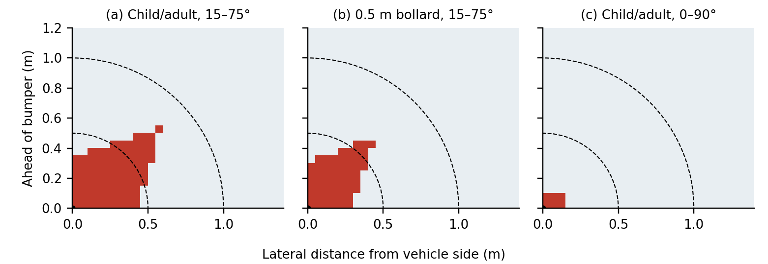
Fig. 2. Infeasible zone (red) for straight seams at the front-left corner, in coordinates relative to the vehicle corner (black dot); dashed arcs are 0.5 m and 1.0 m. (a) Objects taller than both cameras (child, adult), seams 15–75°, β = 6°. (b) A 0.5 m bollard, same settings. (c) Child or adult with an unrestricted seam range.

TABLE II
Share of Base Positions That No Straight Seam Can Preserve, by Distance From the Vehicle Corner (β = 6° Unless Stated)
Object and seam range | ≤ 0.5 m | ≤ 1.0 m | ≤ 1.5 m | ≤ 2.0 m | Farthest infeasible base
Child or adult, 15–75° | 91.0 % | 29.8 % | 12.9 % | 7.2 % | 0.81 m
0.5 m bollard, 15–75° | 70.1 % | 18.8 % | 8.2 % | 4.5 % | 0.64 m
Child or adult, 10–80° | 64.7 % | 15.1 % | 6.6 % | 3.6 % | 0.46 m
Child or adult, 5–85° | 35.3 % | 8.2 % | 3.6 % | 2.0 % | 0.32 m
Child or adult, 0–90° | 9.0 % | 2.1 % | 0.9 % | 0.5 % | 0.18 m
Child or adult, 15–75°, β = 3° | 70.6 % | 20.5 % | 9.0 % | 5.0 % | 0.60 m
Child or adult, 15–75°, β = 10° | 100 % | 47.9 % | 21.6 % | 11.9 % | 1.03 m

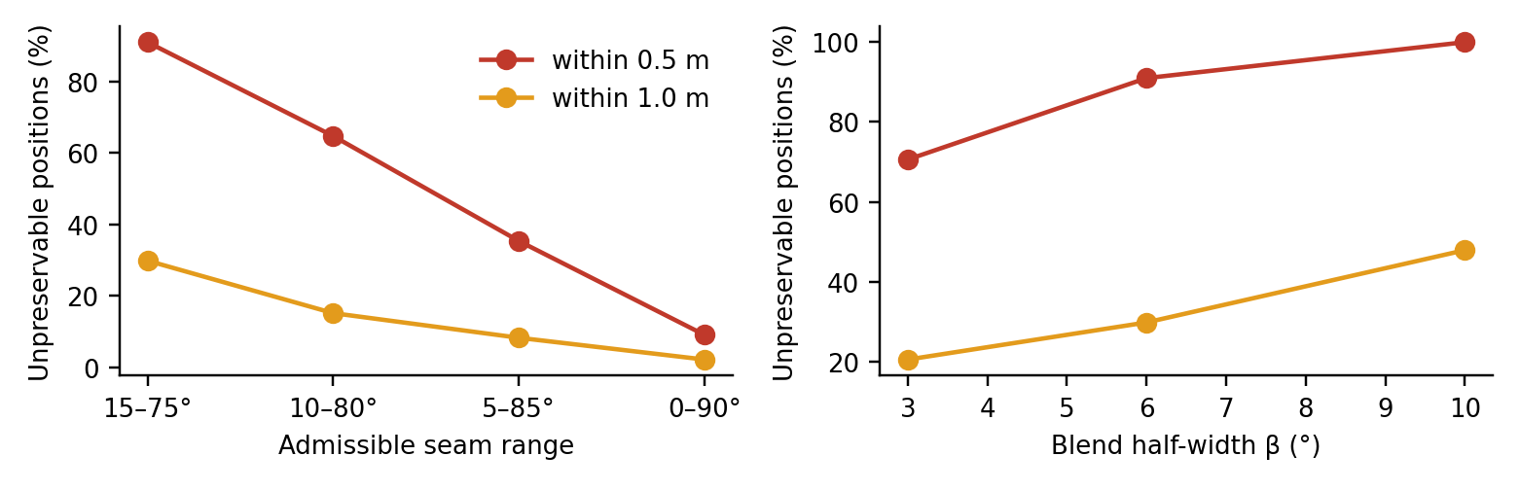
Fig. 3. Share of unpreservable base positions within 0.5 m and 1.0 m of the corner versus admissible seam range (left, β = 6°) and blend half-width (right, seams 15–75°).

With a 15–75° seam range, nine in ten base positions within half a metre of the corner cannot be preserved by any straight seam, and the zone reaches 0.81 m from the corner, exactly where a child stands when walking around a parked car. The share falls to 35 % at 5–85° and to 9 % at 0–90°, and it rises with the blend width. The infeasible zone is therefore a real but design-dependent limitation: it shrinks when steeper seams are allowed, at the cost of showing near-field objects at the fisheye periphery. Prior disclosures handle the case with a default seam [7] or assume the object is large enough to remain visible [10]; Table II shows that the second assumption fails for small VRUs under common seam settings.
V. Uncertainty-Aware Object-Shaped Merging
UA-OSM assigns each object's complete footprint set to one owning camera that actually sees it, widens it by the tracker uncertainty, resolves conflicts jointly, protects unexplained content, and escalates only as far as needed. Fig. 4 shows the pipeline.

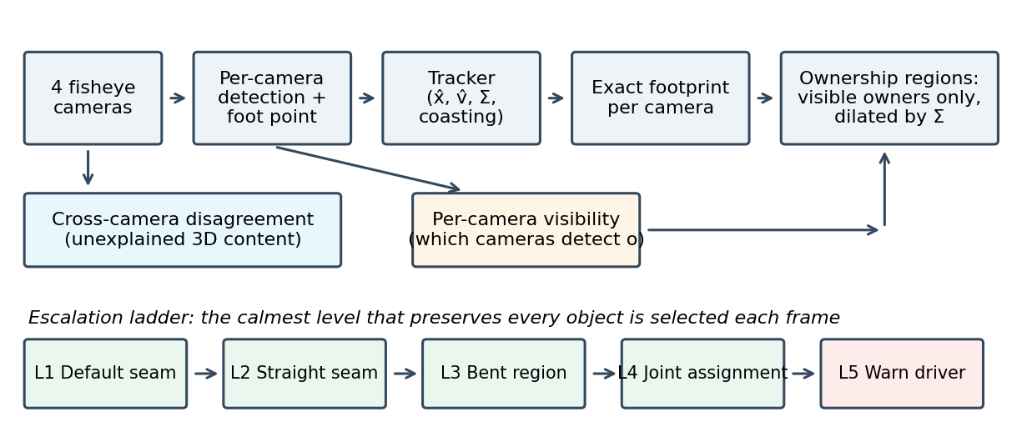
Fig. 4. UA-OSM pipeline (top) and the five-level escalation ladder (bottom).

A. Inputs
Per-camera fisheye detections are projected to the ground through their foot point. Because feet lie on the ground, the same object projects to the same ground location in every camera, which makes cross-camera association a nearest-neighbour problem. Association also yields the visibility set 𝒱(o): the cameras in which object o is currently detected. A person hidden behind another person in one camera produces no detection there. We debounce 𝒱(o) so that a camera's membership changes only after two consistent observations. A constant-velocity Kalman filter [41], [42] provides the state x̂_{o}, velocity v̂_{o}, position covariance Σ_{o} and a coasting flag when an object is temporarily undetected. The class gives a height prior for (2) and a risk weight.
B. Ownership Regions
Given an owner camera c*(o) ∈ 𝒱(o), the ownership region is the union of the object's footprints in all cameras that see its base, each dilated by an uncertainty margin:
$\begin{matrix}R\left(o\right) & =\underset{c}{⋃}dil\left(F_{c}\left(o\right), δ_{o}\right), c^{*}\left(o\right)∈V\left(o\right), \\ δ_{o} & =r_{o}+m_{0}+2σ_{o}, σ_{o}=\sqrt{λ_{max}\left(Σ_{o}\right)}\end{matrix}$ (9)
Inside R(o), pixels visible to c*(o) are drawn from c*(o) only (w = 1). This keeps the owner's copy complete and replaces the other camera's copy, the ghost, with the owner's view of the same ground. Restricting owners to 𝒱(o) matters: assigning an occluded camera would suppress the only real copy of the object. We use m₀ = 0.12 m. For a two-dimensional Gaussian position error, a radius of 2σ_{o} with σ_{o} the largest standard deviation contains at least 86 % of the probability mass (exactly 86 % in the isotropic case); a 95 % radius would require 2.45σ_{o}. While a track is coasting, σ_{o} grows by 0.03 m per 0.1 s up to 0.5 m.
C. Joint Camera Assignment
With several objects in one overlap, regions of different owners can overlap and a region can hide part of another object. Let a assign an owner to each object whose base is seen by two cameras. We minimise
Ja=o​ωo1−OVIoa+λuo​daoomincdco+λso​1ao≠aot−1, ao∈Vo (10)
The first term is the predicted OVI loss evaluated on the estimated states with the analytic model (4), weighted by risk. The second prefers the closer camera, a proxy for pixel density on the object. The third penalises owner switches between frames. The risk weight is ω_{o} = γ_{class}(1 + 1/(0.5 + d_{o})), with d_{o} the distance to the vehicle outline in metres and γ = 1.6 for children, 1.0 for adults, 0.8 for unknown objects and 0.5 for poles. Regions are painted in decreasing ω_{o}, so the most vulnerable object wins any remaining overlap. With at most two candidate owners per object, the search space is 2^{m}; we enumerate it exactly for m ≤ 6 objects per corner. We use λ_{u} = 0.03 and λ_{s} = 0.25.
D. Unexplained-Content Rule
A region that replaces one camera's pixels could hide an object that only that camera sees and the tracker does not know. UA-OSM therefore protects cross-camera disagreement that no tracked object explains. For corner k we compare the two ground-projected images after Gaussian smoothing G:
$D_{k}\left(x\right)=\frac{1}{3}{∥G*I_{a_{k}}\left(x\right)−G*I_{b_{k}}\left(x\right)∥}_{1}, x∈Ω_{k}\backslash \underset{o}{⋃}R\left(o\right)$ (11)
On the ground plane both images agree, so large D_{k} indicates 3D content. Seeds are pixels within 4.5 m of the vehicle with D_{k} > τ_{s}; they grow through connected pixels with D_{k} > τ_{g}. Each component larger than a minimum area is assigned whole to the camera nearer to its closest point and painted before any object region. Section VII shows that this rule works only under near-perfect calibration; we report it as a proof of concept, not as a validated component.
E. Escalation Ladder
Each frame, UA-OSM selects the lowest level that preserves every tracked object, because a straight seam is visually calmer than bent regions:
- L1 Default seam. No object footprint touches an overlap zone.
- L2 Dynamic straight seam. The best angle φ* ∈ [15°, 75°] yields predicted OVI ≥ 0.95 for all objects and no track is coasting.
- L3 Object-shaped region. One object requires an ownership region.
- L4 Joint assignment. Two or more objects are resolved by minimising (10).
- L5 Driver warning. The best assignment leaves a predicted OVI below 0.9, or a relevant track is coasting. The HMI opens a corner view aimed at the affected object, marks its predicted position and displays a text warning.
L5 is the honest fallback: the top view no longer claims completeness when the system cannot guarantee it.
F. Temporal Behaviour
The straight seam angle is rate-limited to 90°/s. To compensate detection latency τ, states are extrapolated as x̂_{o} + v̂_{o} τ. Owner hysteresis is provided by the switching term in (10) and by the debounced visibility set.
Algorithm 1: UA-OSM, one frame per corner k
Input: tracks {x̂o, v̂o, Σo, coasting_o}, visibility V(o),
images Ia, Ib, owners a(t−1)
1: predict x̂o ← x̂o + v̂o·τ; δo ← ro + m0 + 2σo
2: Ok ← objects whose footprints touch Ωk
3: U ← unexplained components of Dk outside ∪R(o)
4: if Ok = ∅: level ← L1; return default seam + U
5: φ* ← argmin_φ Σo (1 − OVIo(φ)) + smoothness
6: if min OVIo(φ*) ≥ 0.95 and no coasting:
level ← L2; return φ* + U
7: a* ← argmin J(a), ao ∈ V(o), over 2^m assignments
8: paint U, then R(o) in decreasing ωo, over φ*
9: if min OVIo(a*) < 0.9 or any coasting:
level ← L5 (warn driver)
10: else level ← L3 if m = 1 else L4

G. Complexity
Evaluating one assignment costs O(m N_{s}) footprint samples, and at most 2^{m} assignments are evaluated. Painting the weight map costs O(P·|R|) for P output pixels and |R| capsule-shaped regions, which maps directly to a fragment shader. Our unoptimised single-core NumPy prototype needs a median of 13 ms for assignment with five objects and 28 ms for a 440 × 440 weight map. We have not measured an embedded or GPU implementation.
VI. Experimental Setup
Headline results are computed with the pixel-level metric (6) on ray-traced renderings, which is independent of the analytic model the methods use for planning. The analytic metric (5) is reported alongside it to quantify how far the two disagree. All code, scenario seeds and configuration files will be released with the paper.
A. Simulator
The renderer ray-traces four equidistant fisheye cameras (192° field of view, 400 × 400 pixels) mounted on a 1.9 × 4.6 × 1.45 m vehicle. Camera poses are listed in Table III. The ground carries asphalt texture, parking-bay lines and a pedestrian crossing. Pedestrians and children are rendered as articulated bodies (legs, torso, arms, head), poles as thin cylinders, with shading and cast shadows. The flat-ground top view covers ±7.2 m at 440 × 440 pixels (3.3 cm per pixel). For the pixel metric, each camera additionally renders a per-object identity image that is warped with the same projection.
TABLE III
Camera Configuration
Camera | Position x, y, z (m) | Pitch | Direction
Front | 0, −2.35, 0.65 | 30° | Forward
Rear | 0, +2.35, 0.95 | 35° | Rearward
Left | −1.00, −0.90, 1.00 | 45° | Left
Right | +1.00, −0.90, 1.00 | 45° | Right

B. Scenarios
The main benchmark contains 105 random scenes at the front-left corner, 21 for each object count k = 1, …, 5. Object bases are drawn uniformly in x ∈ [−4.5, −1.05] m and y ∈ [−5.5, −2.35] m with at least 0.6 m spacing. Classes are children (35 %, 1.1 m), adults (50 %, 1.75 m) and poles (15 %, 2.2 m, r = 0.09 m). Moving objects walk at 0.2–1.3 m/s in random directions and reflect at the region boundary. Each scene runs for 4 s at 10 Hz; the pixel metric is evaluated every second frame. Sensitivity studies use 30 further scenes per condition. Operating-condition tests use 20 scenes each: driving forward past objects at 1.0 m/s (front-left corner, objects start 3–8.5 m ahead) and reversing at 0.8 m/s towards objects behind the rear-left corner, the zone addressed by UN R158 [4]. Five scripted scenes (walk-by, child at corner, crowd of five, undetected trolley, running child) are used for qualitative results and the accompanying video.
C. Perception Model
Detections reach the merger with latency L and are extrapolated with the estimated velocity. Position error follows an Ornstein–Uhlenbeck process with standard deviation σ and correlation time 0.6 s, which reproduces the slowly drifting error of a tracker rather than white noise. Track losses occur at rate p per object-second and last 1 s, during which the track coasts. The main setting is σ = 8 cm, L = 100 ms and p = 0.1 s⁻¹. The visibility set 𝒱(o) is simulated from the rendered fisheye images: a camera detects o when at least 40 % of the object's unoccluded pixels are visible. Against the rendered ground truth, this signal flags 41 of 45 real occlusions with 6 false alarms among 405 unoccluded object–camera pairs. Perception stress tests (20 scenes) add class confusion, in which 20 % of children and adults are reported with the other class's height and risk prior, and phantom tracks, false pedestrian tracks at random positions appearing at 0.3 s⁻¹ and lasting 1 s. A covariance test sets the true error to σ = 20 cm while the tracker reports 10, 20 or 40 cm. All parameters and seeds are listed in Appendix A.
D. Methods Compared
Table IV lists the baselines and ablations. All methods receive the same predicted detections, so differences come from the merging strategy. Each baseline is reported in its better configuration: giving B2 the visibility signal made it worse (Section VII-C), so B2 is evaluated without it.
TABLE IV
Baselines and Ablations
Method | Description
B1 Fixed seam | 45° diagonal seam, β = 6°, industry default [3]
B2 Straight dynamic seam | Exhaustive angle search over 15–75° in 2.5° steps, minimising predicted OVI loss plus smoothness, rate-limited to 90°/s; representative of object-avoiding straight seams [10]
B3 One camera per object | Nearest camera owns each object independently, no dilation, fixed base seam ([9], [11]-style)
B4 Curved mask-avoiding seam | Seam angle as a function of distance from the corner, found by dynamic programming that minimises risk-weighted crossings of the dilated projected masks of both cameras, seams of any shape within 0–90° ([7], [8]-style)
A5 w/o joint assignment | Full UA-OSM, but each object independently owned by its nearest visible camera
A6 w/o visibility | Full UA-OSM without the visibility set (owners may be occluded cameras)
A2 w/o dilation | Full UA-OSM with σ_{o} = 0 in (9)
A3 w/o prediction | Full UA-OSM without latency compensation
A4 w/o unexplained rule | Full UA-OSM; rendered unknown-object tests only
UA-OSM (full) | Sections V-A to V-F

E. Scenario Catalog: Time of Day, Weather and Object Density
To test whether the advantage holds across operating conditions, we built a catalog of 12 conditions: four times of day (morning, afternoon, evening, night) crossed with three weather states (clear, rain, fog), each with one to five objects per corner. The ray-traced top view and the pixel metric are defined by geometry and object identity, not by illumination, so conditions enter the evaluation through their effect on perception: position error, track losses, class confusion and false detections. Table V lists the degradation assumed for each factor. These values are engineering assumptions chosen to span plausible conditions, not measurements; the error level for good conditions follows the roughly 10 cm precision targeted for near-field fisheye perception [1]. Each condition uses the same 10 scene seeds (two per object count), so conditions are compared on identical geometry. Fig. 5 illustrates how the front camera image changes across the catalog.
TABLE V
Scenario Catalog: Assumed Perception Degradation per Time of Day and Weather (Latency 100 ms Throughout)
Factor | Position error σ | Track losses (s⁻¹) | Class swaps | False detections (s⁻¹)
Morning (low sun, glare, long shadows) | 8 cm | 0.03 | 5 % | 0.10
Afternoon (high sun) | 6 cm | 0.01 | 3 % | 0.05
Evening (blue hour, mixed artificial light) | 10 cm | 0.04 | 8 % | 0.15
Night (artificial light only) | 14 cm | 0.08 | 12 % | 0.30
Weather: clear | × 1.0 | + 0 | + 0 | + 0
Weather: rain (droplets, spray, reflections) | × 1.4 | + 0.04 | + 5 % | + 0.30
Weather: fog (reduced range and contrast) | × 1.6 | + 0.06 | + 8 % | + 0.10

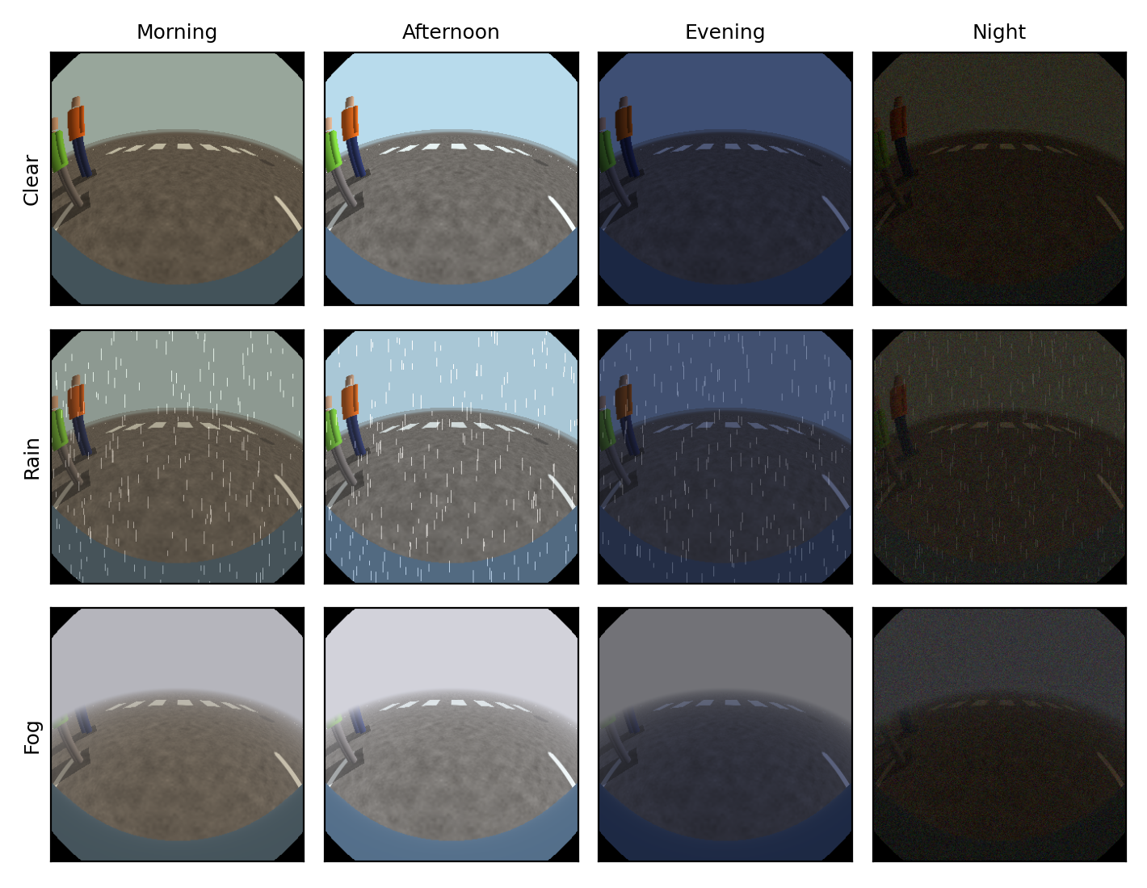
Fig. 5. Illustrative front-camera renderings of the 12 catalog conditions (a pedestrian and a child near the front-left corner). The renderings show appearance only; in the evaluation, conditions act through the perception parameters of Table V.

F. Real-World Appearance Check
The photometric unexplained-content rule depends on how strongly real clothing differs from asphalt, which the simulator can only assume. We therefore took seven smartphone photographs of an adult pedestrian (the author, who consents to publication) beside parked cars in a supermarket car park in Germany on 26 September 2026 between 19:50 and 19:53, at dusk turning to night, in dry weather, under floodlights and street lights. In six photographs we marked regions of the shirt, the jeans, the shoes and nearby asphalt, blurred the image as in (11), and computed the mean absolute 8-bit RGB difference between each clothing region and the asphalt, the same quantity the rule thresholds. These photographs do not validate merging: they come from one handheld camera, not from four synchronised vehicle fisheye cameras, and smartphone tone mapping differs from automotive image processing. They test only the appearance assumption behind Table XIII.
G. Metrics and Statistics
We report the frame-averaged worst-object pixel OVI and the share of frames with at least one lost object, each with a 95 % bootstrap confidence interval over scenes (4,000 resamples). UA-OSM is compared with every other method per scene using the paired Wilcoxon signed-rank test with Holm correction for multiple comparisons; effect size is the matched-pairs rank-biserial correlation, and we also give the median paired difference. Agreement between analytic and pixel OVI is reported as the Pearson correlation over evaluated frames.
H. Unknown Objects and Calibration Error
For the unexplained-content rule, 30 rendered single-object scenes (10 shopping trolleys, 10 adults, 10 children) are generated and the object is withheld from the tracker. We sweep the seed threshold τ_{s} ∈ {35, 45, 60} with τ_{g} = max(15, τ_{s}/2) in 8-bit intensity units. To measure false alarms, we render empty scenes while perturbing every camera's true yaw and pitch by N(0, e²) with e ∈ {0, 0.25, 0.5, 1, 2}°, keeping the nominal calibration for projection, with 8 trials per level (one at 0°).
VII. Results
On rendered pixels, UA-OSM reduces the share of frames with a lost object from 19.9 % for the straight dynamic seam to 7.0 %, and its advantage grows with the number of objects. Pixel-level evaluation also exposed two flaws of an earlier version of the method, which are corrected in the version reported here.
A. Main Benchmark

TABLE VI
Main Benchmark on Rendered Pixels: 105 Scenes, σ = 8 cm, L = 100 ms, p = 0.1 s⁻¹ (Brackets: 95 % Bootstrap Intervals)
Method | Pixel OVI | Frames with a lost object (pixel) | Analytic OVI | Analytic lost frames | r (analytic, pixel)
B1 Fixed seam | 0.427 [0.370, 0.486] | 63.0 % [56.2, 69.9] | 0.488 | 57.5 % | 0.93
B2 Straight dynamic seam | 0.799 [0.758, 0.838] | 19.9 % [15.6, 24.3] | 0.888 | 11.3 % | 0.70
B3 One camera per object | 0.734 [0.684, 0.782] | 27.6 % [22.3, 33.1] | 0.806 | 20.4 % | 0.79
B4 Curved mask-avoiding seam | 0.774 [0.729, 0.814] | 24.0 % [19.4, 28.6] | 0.845 | 16.8 % | 0.78
A5 w/o joint assignment | 0.785 [0.738, 0.828] | 22.4 % [17.3, 27.6] | 0.789 | 22.7 % | 0.78
A6 w/o visibility | 0.896 [0.869, 0.921] | 9.2 % [6.8, 11.9] | 0.987 | 0.7 % | 0.25
UA-OSM (full) | 0.916 [0.895, 0.937] | 7.0 % [4.9, 9.2] | 0.923 | 7.3 % | 0.45

Table V gives the main result. Nine object-frames (0.1 %) in which an object was hidden from every camera were excluded for all methods alike. Table VI shows that UA-OSM outperforms every baseline and ablation after Holm correction, with large effects against all baselines (rank-biserial 0.79–1.00). The median per-scene gain over B2 is 0.053 OVI; the gain is concentrated in crowded scenes (Section VII-B).
TABLE VII
Paired Comparison of UA-OSM With Each Method (Pixel OVI per Scene, n = 105)
Compared method | Wilcoxon p | Holm-adjusted p | Rank-biserial r | Median paired difference
B1 Fixed seam | 2.7 × 10⁻¹⁸ | 1.6 × 10⁻¹⁷ | 1.00 | 0.527
B4 Curved mask-avoiding seam | 2.9 × 10⁻¹⁶ | 1.5 × 10⁻¹⁵ | 0.93 | 0.075
B2 Straight dynamic seam | 1.1 × 10⁻¹³ | 4.2 × 10⁻¹³ | 0.92 | 0.053
A5 w/o joint assignment | 3.2 × 10⁻¹² | 9.5 × 10⁻¹² | 0.99 | 0.059
B3 One camera per object | 4.2 × 10⁻¹² | 8.3 × 10⁻¹² | 0.79 | 0.117
A6 w/o visibility | 0.022 | 0.022 | 0.36 | 0.000

Three findings stand out. First, removing joint assignment (A5) returns UA-OSM to the level of the straight dynamic seam, so joint assignment is the decisive component. Second, the curved mask-avoiding seam (B4) is worse than the straight seam. In a pilot on 40 scenes, giving B4 more freedom made it worse still (17 % to 36 % lost frames under the analytic metric). Avoiding every projected mask stops being informative once a cut is unavoidable, because the objective cannot tell a harmless cut through a ghost from a harmful cut through the only complete copy. Third, the visibility set gives a smaller but significant gain (A6 vs full).
B. Object Density

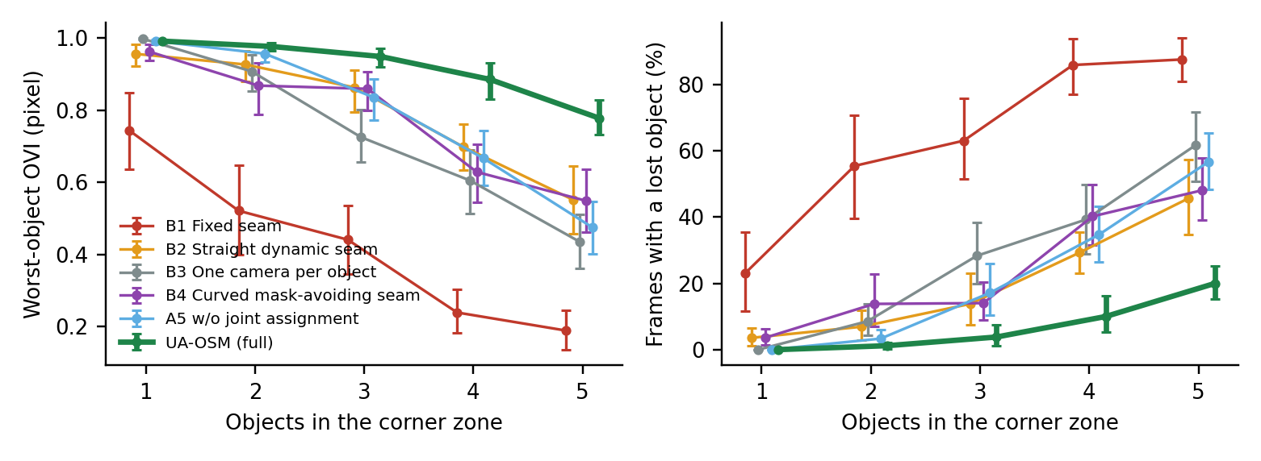
Fig. 6. Pixel-level worst-object OVI (left) and frames with a lost object (right) versus the number of objects in the corner zone; 21 scenes per point, error bars are 95 % bootstrap intervals.

With one object, every object-aware method works: B2 loses an object in 3.6 % of frames and UA-OSM in none. With five objects, B2 loses one in 45.7 % of frames, B4 in 48.1 % and A5 in 56.7 %, while UA-OSM loses one in 20.0 % (Fig. 5). UA-OSM therefore more than halves the loss rate where prior art fails most, but it does not eliminate it: crowded corners remain the main residual failure.
C. Why Analytic Evaluation Was Misleading
An earlier version of this work reported far lower loss rates under the analytic metric. Pixel-level evaluation revealed two flaws. First, the footprint model capped the projected length of tall objects, so ownership regions stopped short of the true smear; the exact form (2) removes this. Second, owners were chosen without regard to occlusion, so a person hidden from the owning camera was erased; restricting owners to 𝒱(o) addresses this (A6 vs full). Even after both corrections, the analytic metric remains optimistic for UA-OSM, because UA-OSM optimises it: its analytic and pixel OVI correlate only weakly (r = 0.45), whereas for the fixed seam, which does not plan, they agree closely (r = 0.93, Table V). This is direct evidence that model-matched evaluation would overstate the benefit of any method that plans with the evaluation model.
Giving B2 the same visibility signal made it worse on a 15-scene subset (19.7 % to 28.7 % lost frames). When an object is hidden from one camera, only one copy can be preserved, which pushes a single straight seam to one extreme; with several objects it jumps between conflicting targets. Its mean motion doubled (2.7° vs 1.3° per frame) and it sat at its rate limit in 24 % of frames instead of 9 %. Local ownership regions do not have this conflict.
D. Detection Error
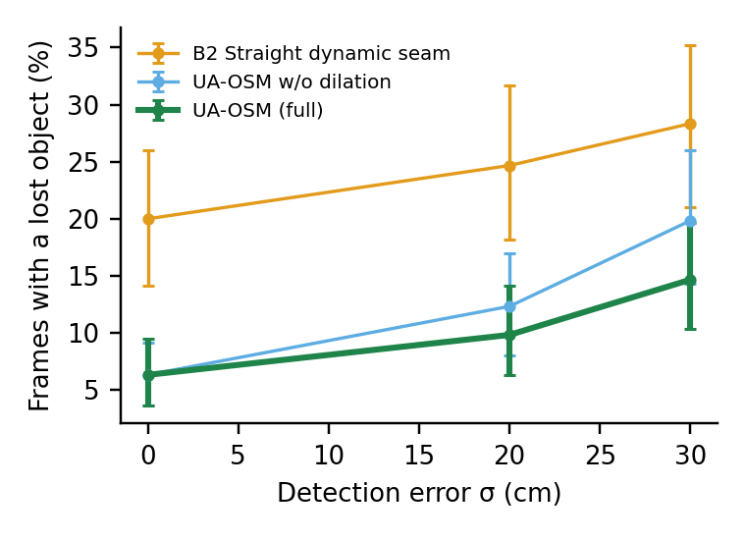
Fig. 7. Pixel-level frames with a lost object versus detection error σ; 30 scenes per point, no track losses, error bars are 95 % bootstrap intervals.
With perfect detections, dilation is unnecessary (6.3 % lost frames with or without it). As σ grows, dilation helps: at σ = 20 cm it reduces the lost-frame rate from 12.3 % to 9.8 %, and at σ = 30 cm from 19.8 % to 14.7 %, a reduction of about 20–25 %. B2 reaches 28.3 % at σ = 30 cm (Fig. 6).
E. Latency and Prediction
TABLE VIII
Pixel-Level Frames With a Lost Object Versus Detection Latency (30 Scenes, σ = 8 cm, No Track Losses)
Latency and prediction | B2 Straight dynamic seam | UA-OSM (full)
100 ms, with prediction | 20.8 % | 6.5 %
300 ms, with prediction | 23.5 % | 7.3 %
300 ms, without prediction | 25.2 % | 10.8 %

As Table VII shows, constant-velocity prediction keeps UA-OSM within one percentage point of its 100 ms result at 300 ms latency; without prediction the lost-frame rate rises to 10.8 %.
F. Operating Conditions: Ego Motion and Reversing
TABLE IX
Pixel-Level Results Under Ego Motion (20 Scenes Each, σ = 8 cm, L = 100 ms, p = 0.02 s⁻¹)
Scenario | Method | Pixel OVI | Frames with a lost object
Driving forward past objects, front-left, 1.0 m/s | B1 Fixed seam | 0.482 | 54.6 %
 | B2 Straight dynamic seam | 0.770 | 22.8 %
 | UA-OSM | 0.889 | 10.3 %
Reversing towards objects, rear-left, 0.8 m/s | B1 Fixed seam | 0.352 | 71.8 %
 | B2 Straight dynamic seam | 0.682 | 32.8 %
 | UA-OSM | 0.872 | 11.5 %

Table VIII shows that the ranking holds when the vehicle moves and at the rear corner. Reversing is the hardest case for all methods, because objects sweep through the overlap and the seams must follow them; UA-OSM keeps the lost-frame rate close to its static value, while B2 rises to 32.8 %.
G. Perception Robustness
TABLE X
Pixel-Level Frames With a Lost Object Under Perception Errors (20 Scenes Each)
Condition | B2 Straight dynamic seam | UA-OSM
Clean detections, σ = 8 cm, p = 0.02 s⁻¹ | 22.2 % | 5.3 %
+ 20 % class confusion + phantom tracks (0.3 s⁻¹) | 23.0 % | 6.5 %
True σ = 20 cm, reported 10 cm (over-confident) | — | 8.2 %
True σ = 20 cm, reported 20 cm (calibrated) | — | 7.5 %
True σ = 20 cm, reported 40 cm (under-confident) | — | 7.5 %

Class confusion and phantom tracks raise UA-OSM's lost-frame rate by 1.2 percentage points (Table IX): a wrong height prior changes the planned footprint length, and a phantom claims an ownership region that can cover part of a real object. An over-confident tracker, which reports half the true error, costs 0.7 points; an under-confident one costs nothing here, because the wider regions did not collide more often at this density.
H. Parameter Sensitivity
TABLE XI
Sensitivity of UA-OSM to Its Parameters (20 Scenes, No Track Losses; Default in Bold)
Parameter | Values | Frames with a lost object
Switch penalty λ_{s} | 0 / 0.25 / 1.0 | 5.5 % / 5.3 % / 9.2 %
Region margin m₀ | 0.05 / 0.12 / 0.25 m | 5.0 % / 5.3 % / 6.2 %
Level-2 threshold | 0.90 / 0.95 / 0.99 | 6.2 % / 5.3 % / 5.5 %

Results vary by at most one percentage point across the tested margins and level-2 thresholds, and by 0.2 points when owner switching is not penalised at all (Table X). Only a large switch penalty hurts, because owners then persist after they have stopped being the best choice.
I. Driver Warnings

TABLE XII
How Often the L5 Warning Fires, and How Often a Loss Goes Unwarned (UA-OSM; 20 Scenes Each)
Condition | Frames at L5 | L5 frames with an actual lost object | Frames with an unwarned loss
No track losses | 9.2 % | 27 % | 2.8 %
Track losses 0.02 s⁻¹ | 13.8 % | 18 % | 2.8 %
Track losses 0.1 s⁻¹ | 25.5 % | 15 % | 2.5 %
Driving forward, 0.02 s⁻¹ | 24.9 % | 25 % | 4.0 %
Reversing, 0.02 s⁻¹ | 17.5 % | 43 % | 4.4 %
B2 (never warns), 0.02–0.1 s⁻¹ | — | — | 22.2–23.5 %

The ladder reduces unwarned losses from 22–24 % of frames with B2 to 2.5–4.4 % (Table XI), but it does so by warning often and imprecisely. L5 fires in 9–25 % of frames, and only 15–43 % of those frames contain an actual lost object, mainly because any coasting track triggers it. At these rates the warning would likely cause alert fatigue; Section VIII discusses how to make it more selective.
J. Unexplained-Content Rule

TABLE XIII
Undetected Objects, Pixel-Level (30 Rendered Scenes; No Track Is Provided)
Seed threshold τ_{s} | Components found | Mean OVI | Objects lost | Trolley / adult / child OVI
Rule disabled (A4) | — | 0.589 | 50.0 % | 0.56 / 0.71 / 0.50
60 | 43 % | 0.687 | 40.0 % | 0.85 / 0.71 / 0.50
45 | 73 % | 0.802 | 23.3 % | 1.00 / 0.90 / 0.50
35 | 100 % | 0.804 | 23.3 % | 1.00 / 0.91 / 0.51

Table XII shows that the rule recovers undetected trolleys completely and adults largely at τ_{s} ≤ 45, but not children, whose grey legs differ little from asphalt, so the grown region covers only part of the footprint. Low-contrast clothing is a genuine weakness of photometric disagreement.

TABLE XIV
False Unknown-Object Components on Empty Scenes Under Extrinsic Calibration Error
Calibration error (1σ) | τ_{s} = 60: trials with a false component | τ_{s} = 60: false area | τ_{s} = 35: trials with a false component | τ_{s} = 35: false area
0° (1 trial) | 0 % | 0 m² | 100 % | 3.1 m²
0.25° | 13 % | 0.2 m² | 75 % | 3.6 m²
0.5° | 75 % | 3.3 m² | 88 % | 9.4 m²
1.0° | 75 % | 4.5 m² | 100 % | 12.4 m²
2.0° | 100 % | 13.0 m² | 100 % | 20.0 m²

Table XIII shows the other side of the trade-off: the thresholds that detect undetected objects also fire on empty ground. At τ_{s} = 35, resampling differences at painted markings already produce false components with perfect calibration; at τ_{s} = 60, half a degree of calibration error triggers false components in three of four trials. A false component hides nothing, since it only assigns ground pixels to one camera, but it would raise unnecessary "unknown object" warnings. With 8 trials per level these rates are coarse. The rule is therefore a proof of concept.
K. Performance Across Times of Day, Weather and Density

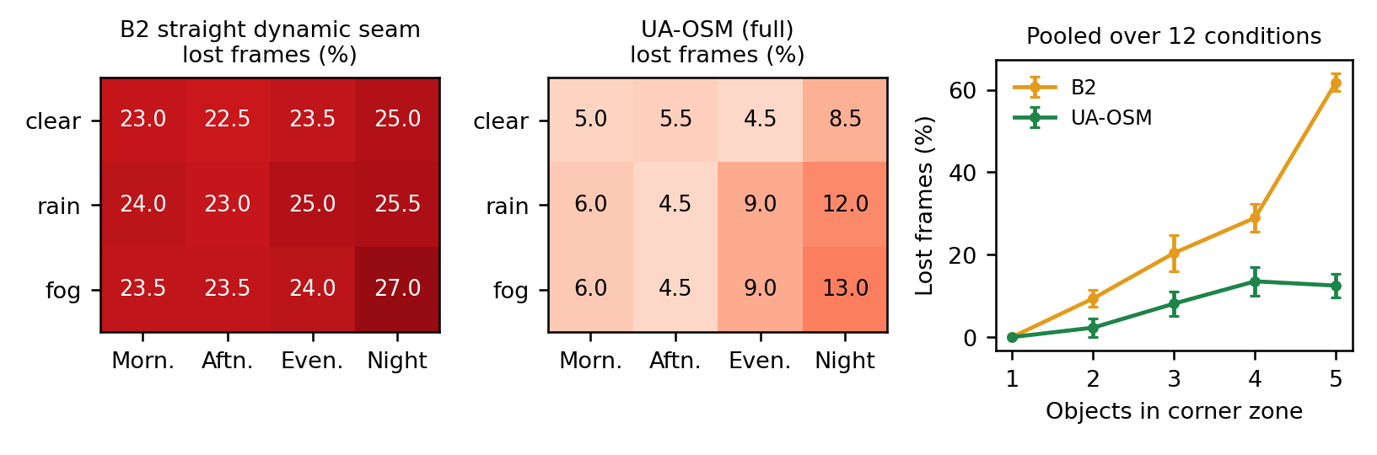
Fig. 8. Pixel-level frames with a lost object for the 12 catalog conditions (left: B2, centre: UA-OSM; 10 scenes each) and, pooled over all conditions, versus the number of objects in the corner zone (right; 24 scenes per point, error bars 95 % normal intervals).

TABLE XV
Results per Catalog Condition (Pixel-Level; 10 Scenes, Two per Object Count)
Condition | B2 lost frames | UA-OSM lost frames | UA-OSM frames at L5
Morning, clear | 23.0 % | 5.0 % | 16.5 %
Afternoon, clear | 22.5 % | 5.5 % | 5.5 %
Evening, clear | 23.5 % | 4.5 % | 18.0 %
Night, clear | 25.0 % | 8.5 % | 26.0 %
Morning, rain | 24.0 % | 6.0 % | 24.0 %
Afternoon, rain | 23.0 % | 4.5 % | 22.0 %
Evening, rain | 25.0 % | 9.0 % | 26.0 %
Night, rain | 25.5 % | 12.0 % | 37.5 %
Morning, fog | 23.5 % | 6.0 % | 27.0 %
Afternoon, fog | 23.5 % | 4.5 % | 24.0 %
Evening, fog | 24.0 % | 9.0 % | 27.5 %
Night, fog | 27.0 % | 13.0 % | 40.0 %

UA-OSM loses fewer objects than B2 in all 12 conditions (Fig. 8, Table XV): 4.5–13.0 % against 22.5–27.0 % of frames, a ratio between 0.19 and 0.48. The two methods respond differently to conditions. B2 is almost flat, because its losses are geometric: even with good perception a single straight seam cannot serve several objects near the corner. UA-OSM's remaining losses come from perception, so it degrades as seeing gets harder, from 4.5 % in afternoon or evening clear weather to 12–13 % at night in rain or fog. Its advantage is therefore largest in good conditions and smallest at night in poor weather. Warnings follow the same pattern and reach 37.5–40 % of frames at night in rain or fog, which reinforces the alert-fatigue concern of Section VIII.
Pooled over all conditions, object density dominates: B2 loses an object in 0 %, 9.4 %, 20.4 %, 29.0 % and 61.9 % of frames for one to five objects, UA-OSM in 0 %, 2.3 %, 8.1 %, 13.5 % and 12.5 %. With 10 scenes per condition the intervals are wide, so differences between neighbouring conditions are not significant; the consistent sign across all 12 conditions and the density trend are the robust findings.
L. Real-World Appearance Evidence

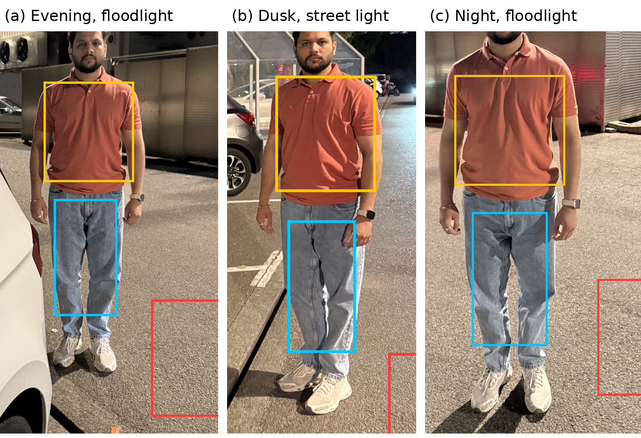
Fig. 9. Three of the real photographs used for the appearance check, cropped to the pedestrian; boxes mark the shirt (yellow), jeans (cyan) and asphalt (red) regions. (a) Evening, floodlight. (b) Dusk, street light. (c) Night, floodlight. The pedestrian is the author.

TABLE XVI
Clothing–Asphalt Difference in Real Photographs (Mean Absolute 8-bit RGB Difference After Blurring, as Thresholded by the Unexplained-Content Rule)
Photo and lighting | Shirt (orange) | Jeans (light blue) | Shoes (white)
1 Night, floodlight | 65.3 | 45.8 | 16.4
2 Evening, walking | 68.4 | 33.6 | —
3 Evening, floodlight | 59.1 | 40.2 | 46.9
4 Dusk, street light | 53.8 | 35.6 | 9.3
5 Night, floodlight | 27.2 | 26.1 | —
6 Dusk, floodlight | 31.4 | 18.7 | 37.5

Table XVI shows that the brightly coloured shirt exceeds a threshold of 45 in four of six photographs, but the jeans exceed it in only one and the shoes in one of four. The lower body, which dominates the footprint projected by the low front camera, is therefore mostly below the thresholds at which the rule avoids false alarms (Table XIV). This real evidence agrees with the simulated finding that the rule misses objects with low-contrast lower bodies, and the simulated adult's legs (difference 34) fall inside the measured range of 19–46. The sample is one person, one car park and one evening; it supports the appearance assumption but is not a representative measurement.
M. Qualitative Results
Fig. 1 shows the crowded-corner scene with detection error switched off. B1 loses three of the five objects and cuts a fourth; B2 recovers most of them but still loses the child at the corner (object 1), which stands in the infeasible zone of Table II; UA-OSM shows all five whole. The accompanying video shows five scripted scenes with the in-vehicle display, including an L5 warning while a child's track is lost behind an adult.
VIII. Discussion
Within the limits of simulation, the results support a shift in the design goal of surround-view merging from a seamless image towards a complete one: each object shown whole where the cameras allow it, and an explicit warning where they do not. Whether drivers benefit from this shift has not yet been tested.
A. Implications for the HMI
The object-shaped regions appear only when a straight seam cannot preserve every object; in the five scripted scenes of the accompanying video, UA-OSM stayed at levels L1–L2 for 60 % of frames. L5 changes the contract between system and driver: instead of a top view that silently degrades, the driver is directed to a corner view of the affected object. Showing an enlarged view of the nearest obstacle beside the top view is itself known [43]; here the view is triggered by a loss of display completeness rather than by distance alone. Replacing the object with a symbol [27] also removes ghosts, but it discards camera evidence; we expect, but have not shown, that drivers use that evidence to judge what the object is and where it is heading.
The warning statistics in Table XI are the main open HMI problem. L5 currently fires whenever a relevant track coasts, which makes it frequent and imprecise. Three refinements are straightforward: warn only for coasting tracks within a distance threshold of the vehicle outline, require the predicted loss to persist for several frames, and use the corner view without a text warning for lower-risk cases. Field evidence that camera benefit depends on the object's position in the image [6] suggests that the combination of a complete top view and a targeted corner view is worth testing, but the right warning policy must come from a driving-simulator study that measures detection time, glance behaviour and alert fatigue.
B. Failure Analysis
The remaining losses have three sources. First, density: with four or five objects in one overlap, regions of differently owned objects overlap and the lowest-risk object is cut (10–20 % lost frames, Fig. 5). Second, perception: coasting tracks, class confusion and over-confident covariance place regions in the wrong place or with the wrong length (Tables IX and XI). Third, the planning model: UA-OSM plans with the analytic footprint, which agrees only weakly with rendered pixels (r = 0.45), so a region that looks sufficient to the planner can miss part of the true projection. The third source is the most promising to reduce, for example by planning with projected detection masks instead of cylinders.
C. Safety Analysis View
Under ISO 21448 [5], the lost-object failure is a performance limitation with identifiable triggering conditions. Table XIV maps them to UA-OSM mechanisms and residual risk. The same structure can seed a SOTIF analysis for series development.

TABLE XVII
Triggering Conditions, Mitigations and Residual Risk (Simulation Evidence)
Triggering condition | Effect without mitigation | UA-OSM mechanism | Residual risk (pixel-level)
Object within ~0.8 m of the vehicle corner | No straight seam preserves it (Table II) | Ownership region (L3) | See density row
Several objects in one overlap | Seams or regions conflict (Proposition 2) | Joint assignment (L4), risk-ordered painting | 20.0 % lost frames with five objects
Object hidden from one camera by another object | Owner camera shows no copy; object erased | Owners restricted to cameras that detect the object | Depends on per-camera detection quality
Detection error of 20–30 cm | Objects fall outside regions | Covariance dilation | 9.8–14.7 % lost frames
Detection latency up to 300 ms | Regions lag moving objects | Velocity prediction | 7.3 % lost frames at 300 ms
Class confusion, phantom tracks | Wrong footprint length; spurious regions | None specific | 6.5 % lost frames (vs 5.3 % clean)
Vehicle reversing towards objects | Objects sweep through the overlap | As above; ego motion handled by tracking | 11.5 % lost frames
Track lost (occlusion, low confidence) | Object unprotected | Coasting with growing σ, L5 warning | Unwarned loss 2.5–4.4 % of frames; warning precision 15–43 %
Object class unknown to detector | No region created | Disagreement rule (proof of concept) | False alarms under calibration error (Table XIII)
Object below camera coverage at the bumper | Not imaged by any camera | None (physical limit) | Requires ultrasonic warning

D. Operational Design Domain and Safety Process
The evidence in this paper covers a bounded operational design domain: low-speed manoeuvring up to about 1 m/s, flat ground, daylight rendering, calibrated cameras, one vehicle geometry, and up to five pedestrians, children or poles per corner. Outside this domain, for example on slopes, at night, in rain or with lens soiling, the results do not apply. For series development we suggest acceptance criteria of the form "frames with an unwarned loss of a vulnerable road user below a target rate within the ODD", validated on recorded data. Because UA-OSM adds a safety-relevant output, the L5 warning, the item definition and hazard analysis of the display function under ISO 26262 [44] would have to be revisited; the resulting integrity level depends on the item definition and is outside the scope of this paper.
E. Making the Unexplained-Content Rule Deployable
The rule's weakness is photometric: calibration error and resampling differences create disagreement on flat ground. Confirmation by ultrasonic sensors or a free-space estimate would gate components before they reach the HMI. Temporal persistence, requiring a component to exist over several frames while the vehicle moves, would suppress static calibration artefacts. Comparing images in a representation that is less sensitive to small misalignment, such as learned features or census transforms, may reduce false components at painted markings.
F. Threats to Validity
- Simulation fidelity. The renderer assumes flat ground, ideal fisheye optics, perfect photometric consistency and daylight, and represents people as articulated cylinders. Curbs, slopes, rolling shutter, motion blur, night and weather are absent.
- Metric validity. Pixel-level OVI measures how much of the rendered object is drawn, not whether a driver recognises it. It needs validation against human detection performance.
- Planning model. UA-OSM plans with the analytic footprint model, which agrees only weakly with rendered pixels (r = 0.45).
- Visibility signal. The per-camera visibility set is simulated from ideal renderings; a real detector adds misses, false detections and association errors beyond those tested in Table IX.
- Baseline fidelity. B2–B4 are our implementations of concepts in patent disclosures [7]–[11], not vendor code, and may differ from production systems.
- Tuning. Weights and thresholds were chosen on the same simulator used for evaluation. Table X shows limited sensitivity, but a held-out real dataset is needed to rule out optimistic bias.
- Sample sizes. Sensitivity and robustness conditions use 20–30 scenes, and the unknown-object tests 30 scenes with 8 calibration trials per level; these rates carry wide uncertainty.
Condition modelling. The time-of-day and weather catalog changes only perception inputs; the effects of noise, glare, exposure differences between cameras and wet reflections on the displayed image are not rendered into the metric, and the degradation values are assumptions.
G. Limitations and Validation Roadmap
All evidence is simulated. Three validation steps are needed before any claim about real vehicles: reproducing the benchmark in CARLA [45] with rendered fisheye cameras and a fisheye detector and tracker in the loop; evaluating on recorded surround-view sequences, for example WoodScape [17], where per-object visibility can be annotated; and a driving-simulator study of detection time and warning acceptance. Further limitations are the flat-ground projection (bowl and 3D views were not evaluated), a single camera layout, runtime measured only on an unoptimised CPU prototype, and exhaustive assignment, which scales as 2^{m} and needs a greedy or branch-and-bound search beyond about six objects per corner.
H. Real-Data Capture Plan
A low-cost path to real validation is a vehicle fitted with four synchronised wide-angle cameras (field of view above 180° or at least 150° with overlapping corners), calibrated intrinsically with a checkerboard and extrinsically against ground markers, and synchronised by hardware trigger or timecode. Recording the scripted scenes of Section VI (walk-by, child-height mannequin at the corner, crowds of one to five people, an undetected object such as a trolley) at the four times of day and in clear, rain and fog conditions would allow pixel-level OVI to be computed from manually annotated instance masks, replacing the simulated visibility set with real detections. Production surround-view recordings with calibration, where available, would serve the same purpose with better image quality.
IX. Conclusion
Straight merge seams, fixed or dynamic, cannot keep small vulnerable road users whole near the vehicle corner: with seams limited to 15–75°, 91 % of base positions within 0.5 m of the corner are unpreservable, and with several objects a single seam fails even when each object alone could be preserved. UA-OSM assigns each object's complete footprint to one camera that detects it, widens it by tracker uncertainty, resolves conflicts jointly and escalates to a driver warning. In simulation, evaluated on rendered pixels, it lowers the share of frames with a lost object from 19.9 % to 7.0 % compared with a straight dynamic seam, from 45.7 % to 20.0 % with five objects, and from 32.8 % to 11.5 % when reversing at a rear corner, and it degrades gracefully under perception errors. Crowded corners, an imprecise warning and the gap between the planning model and the true projection remain open, and all evidence so far is simulated.
Across a catalog of four times of day and three weather states, UA-OSM lost fewer objects than a straight dynamic seam in every condition, with the largest margin in good conditions and the smallest at night in rain or fog, where perception limits it. Real photographs of a pedestrian at dusk and at night confirmed that lower-body clothing contrast is too low for the photometric unknown-object check, but real surround-view recordings are still required to validate the merging itself.
Declarations
Image consent. The person shown in Fig. 9 is the author, who consents to publication. Published crops exclude bystanders and vehicle licence plates.
Code and data availability. The simulator, scenario seeds and scripts that reproduce every table and figure will be deposited in a public, versioned repository on acceptance; they are available to reviewers on request. No external data were used; all data were generated by the simulator described in Section VI.
Competing interests. The author is employed by an automotive supplier that develops surround-view systems. This study was carried out as part of doctoral research at EIMT, Switzerland.
Use of generative AI. Generative AI (Anthropic Claude) was used to assist with simulation code, data analysis, figure generation and drafting. The author reviewed and verified the methods, results and text and takes full responsibility for the content.
Appendix A: Simulation Parameters

TABLE XVIII
Parameters and Seeds Needed to Reproduce the Results
Group | Parameter | Value
Top view | Extent, resolution | ±7.2 m, 440 × 440 px (3.3 cm/px)
Fisheye cameras | Model, field of view, image size | Equidistant, 192°, 400 × 400 px
Straight seams | Range, step, blend β, rate limit | 15–75°, 2.5°, 6°, 90°/s
Curved seam (B4) | Radial step, angle step, max change per step | 0.1 m, 2.5°, 3 steps
Footprint | ℓ_{max} (beyond display edge) | 10.5 m; 12 samples per footprint (planning)
UA-OSM | m₀, λ_{u}, λ_{s}, level-2 / level-5 thresholds | 0.12 m, 0.03, 0.25, 0.95 / 0.90
UA-OSM | Risk weights γ (child, adult, unknown, pole) | 1.6, 1.0, 0.8, 0.5
Visibility | Detection rule, debounce | ≥ 40 % of unoccluded pixels; 2 consistent observations
Perception | σ, correlation time, latency, track-loss rate and duration | 8 cm, 0.6 s, 100 ms, 0.1 s⁻¹ and 1 s (main)
Scenes | Duration, rate, pixel evaluation | 4 s, 10 Hz, every second frame
Seeds | Scene / perception / phantom | 1000 + i / 1000 + i + 7 / 1000 + i + 99 for scene i
Unknown-object rule | Blur, seed radius, minimum area, growth | 15 × 15 Gaussian, 4.5 m, 120 px, τ_{g} = max(15, τ_{s}/2)
Software | Language and libraries | Python 3.12, NumPy 2.4, OpenCV 4.13, SciPy (statistics)
Hardware | Runtime measurements | Single CPU core, unoptimised prototype

References
[1] V. R. Kumar, C. Eising, C. Witt, and S. K. Yogamani, "Surround-view fisheye camera perception for automated driving: Overview, survey & challenges," IEEE Trans. Intell. Transp. Syst., vol. 24, no. 4, pp. 3638–3659, 2023.
[2] C. Eising, J. Horgan, and S. Yogamani, "Near-field perception for low-speed vehicle automation using surround-view fisheye cameras," IEEE Trans. Intell. Transp. Syst., vol. 23, no. 9, pp. 13976–13993, Sep. 2022, doi: 10.1109/TITS.2021.3127646.
[3] V. Appia et al., "Surround view camera system for ADAS on TI's TDAx SoCs," Texas Instruments, Tech. Rep. SPRY270, Oct. 2015.
[4] UNECE, "UN Regulation No. 158: Uniform provisions concerning the approval of devices for means of reversing motion and motor vehicles with regard to the driver's awareness of vulnerable road users behind vehicles," 2021.
[5] Road Vehicles: Safety of the Intended Functionality, ISO 21448:2022.
[6] D. G. Kidd, B. K. Hagoski, T. G. Tucker, and D. P. Chiang, "The effectiveness of a rearview camera and parking sensor system alone and combined for preventing a collision with an unexpected stationary or moving object," Human Factors, 2015, doi: 10.1177/0018720814553028.
[7] Y. Ren, K. Turkowski, N. M. Arar, O. Gallo, J. Kautz, N. Avadhanam, and H. Su, "Image stitching with dynamic seam placement based on object saliency for surround view visualization," U.S. Patent Appl. 18/173,589, Oct. 5, 2023.
[8] Y. Ren, N. M. Arar, O. Gallo, J. Kautz, N. Avadhanam, and H. Su, "Image stitching with dynamic seam placement based on ego-vehicle state for surround view visualization," WO 2023/192752 A1, Oct. 5, 2023.
[9] A. T. Liang, V. Elangovan, D. Ramakrishnan, and P. Jain, "Dynamic seam adjustment of image overlap zones from multi-camera source images," U.S. Patent 10,992,860 B2, Apr. 27, 2021.
[10] M. Gyori and H. Nemeth (Knorr-Bremse Systeme für Nutzfahrzeuge GmbH), "Image synthesizer for a surround monitoring system," U.S. Patent 10,967,790 B2, 2021.
[11] Y.-C. Chen, J.-S. Chen, C.-C. Lee, C.-M. Weng, and C.-N. Hsu, "Processing method for vehicle surround view, vehicle surround view system and in-vehicle processing device," U.S. Patent 12,394,210 B2, 2025.
[12] R. Szeliski, "Image alignment and stitching: A tutorial," Found. Trends Comput. Graph. Vis., vol. 2, no. 1, pp. 1–104, 2007.
[13] A. Hedi and S. Lončarić, "A system for vehicle surround view," IFAC Proc. Vol., vol. 45, no. 22, pp. 120–125, 2012.
[14] P. J. Burt and E. H. Adelson, "A multiresolution spline with application to image mosaics," ACM Trans. Graph., vol. 2, no. 4, pp. 217–236, 1983.
[15] Y. Ren, Y. Deng, D. Pajak, R. Jenkin, N. Avadhanam, and V. Hedau, "Parameter blending for multi-camera harmonization for automotive surround view systems," arXiv:2406.11066, 2024.
[16] L. Zhang, J. Chen, D. Liu, Y. Shen, and S. Zhao, "Seamless 3D surround view with a novel burger model," in Proc. IEEE Int. Conf. Image Process. (ICIP), 2019, pp. 4150–4154.
[17] S. Yogamani et al., "WoodScape: A multi-task, multi-camera fisheye dataset for autonomous driving," in Proc. IEEE/CVF Int. Conf. Comput. Vis. (ICCV), 2019, pp. 9308–9318.
[18] V. Kwatra, A. Schödl, I. Essa, G. Turk, and A. Bobick, "Graphcut textures: Image and video synthesis using graph cuts," ACM Trans. Graph., vol. 22, no. 3, pp. 277–286, 2003.
[19] A. Agarwala et al., "Interactive digital photomontage," ACM Trans. Graph., vol. 23, no. 3, pp. 294–302, 2004.
[20] L. Li, J. Yao, X. Lu, J. Tu, and J. Shan, "Optimal seamline detection for multiple image mosaicking via graph cuts," ISPRS J. Photogramm. Remote Sens., vol. 113, pp. 1–16, 2016.
[21] S. Avidan and A. Shamir, "Seam carving for content-aware image resizing," ACM Trans. Graph., vol. 26, no. 3, 2007.
[22] NVIDIA Corp., "Image stitching with saccade-based control of dynamic seam placement for surround view visualization," U.S. Patent Appl. Pub. 2024/0135487, 2024.
[23] NVIDIA Corp., "Image stitching with an adaptive three-dimensional bowl model of the surrounding environment for surround view visualization," U.S. Patent 12,626,326 B2, 2026.
[24] "Monitoring system and vehicle surrounding monitoring system," U.S. Patent 7,916,899 B2, 2011.
[25] D. Sabo, A. Cohen, A. Wolf, and L. Azaria (Samsung Electronics Co., Ltd.), "Surround view system," U.S. Patent 12,450,825 B2, Oct. 2025.
[26] "Surroundings monitoring device of vehicle," U.S. Patent 10,017,112 B2, 2018.
[27] "Advanced blending of stitched images for 3D object reproduction," U.S. Patent 10,055,643 B2, 2018.
[28] Y. Ren and N. Avadhanam, "Stitching quality assessment for surround view systems," U.S. Patent Appl. 17/381,129, Jan. 26, 2023.
[29] P. C. Madhusudana and R. Soundararajan, "Subjective and objective quality assessment of stitched images for virtual reality," IEEE Trans. Image Process., vol. 28, no. 11, pp. 5620–5635, 2019.
[30] J. Zaragoza, T.-J. Chin, Q.-H. Tran, M. S. Brown, and D. Suter, "As-projective-as-possible image stitching with moving DLT," IEEE Trans. Pattern Anal. Mach. Intell., vol. 36, no. 7, pp. 1285–1298, 2014.
[31] L. Nie, C. Lin, K. Liao, S. Liu, and Y. Zhao, "Unsupervised deep image stitching: Reconstructing stitched features to images," IEEE Trans. Image Process., vol. 30, pp. 6184–6197, 2021.
[32] L. Nie, C. Lin, K. Liao, S. Liu, and Y. Zhao, "Parallax-tolerant unsupervised deep image stitching," in Proc. IEEE/CVF Int. Conf. Comput. Vis. (ICCV), 2023, pp. 7365–7374.
[33] W. Cai and W. Yang, "Object-level geometric structure preserving for natural image stitching," in Proc. AAAI Conf. Artif. Intell., vol. 39, no. 2, 2025, pp. 1926–1934.
[34] L. Sun, H. Liang, Z. Dong, Y. Yang, and M. Fu, "UDSV: Unsupervised deep stitching for tractor-trailer surround view," in Proc. IEEE Int. Conf. Robot. Autom. (ICRA), 2025.
[35] H. Liang, Z. Dong, K. Chen, J. Guo, Y. Yue, M. Fu, and Y. Yang, "ChatStitch: Visualizing through structures via surround-view unsupervised deep image stitching with collaborative LLM-agents," arXiv:2503.14948, 2025.
[36] Y. Jia, R. Wu, R. Song, J. Li, and B. Song, "LiftProj: Space lifting and projection-based panorama stitching," arXiv:2512.24276, 2025.
[37] X. Wei et al., "ParkGaussian: Surround-view 3D Gaussian splatting for autonomous parking," in Proc. IEEE/CVF Conf. Comput. Vis. Pattern Recognit. (CVPR), 2026, arXiv:2601.01386.
[38] S. Sonarghare, P. Deshpande, C. Hogan, D.-R. Kaliappan-Mahalingam, and G. Sistu, "FisheyeGaussianLift: BEV feature lifting for surround-view fisheye camera perception," arXiv:2511.17210, 2025.
[39] D. G. Kidd and A. T. McCartt, "Differences in glance behavior between drivers using a rearview camera, parking sensor system, both technologies, or no technology during low-speed parking maneuvers," Accid. Anal. Prev., vol. 87, pp. 92–101, 2016.
[40] D. G. Kidd, B. Reimer, J. Dobres, and B. Mehler, "Changes in driver glance behavior when using a system that automates steering to perform a low-speed parallel parking maneuver," Transp. Res. Part F Traffic Psychol. Behav., vol. 58, pp. 629–639, 2018.
[41] R. E. Kalman, "A new approach to linear filtering and prediction problems," J. Basic Eng., vol. 82, no. 1, pp. 35–45, 1960.
[42] Y. Bar-Shalom, X. R. Li, and T. Kirubarajan, Estimation with Applications to Tracking and Navigation. New York, NY, USA: Wiley, 2001.
[43] "Surround view monitoring system and providing method of the same," U.S. Patent 11,648,888 B2, 2023.
[44] Road Vehicles: Functional Safety, ISO 26262:2018.
[45] A. Dosovitskiy, G. Ros, F. Codevilla, A. López, and V. Koltun, "CARLA: An open urban driving simulator," in Proc. Conf. Robot Learn. (CoRL), 2017, pp. 1–16.

